|  |  |  |
| --- | --- | --- |
|  |  |  |
| (a) | (b) | (c) |
|  |  |  |
| (d) | (e) | (f) |

Fig. 1. Blueberry health dataset and its enhancement method. (a) Powdery mildew. (b) Leaf anthracnose. (c) Nutrient deficiency. (d) Noise. (e) Rotary scaling. (f) Color transformation

|  |  |
| --- | --- |
|  |  |
| (a) | (b) |

Fig. 2. Comparison of low-resolution images before and after preprocessing. (a) Original image. (b) Pre-processed images

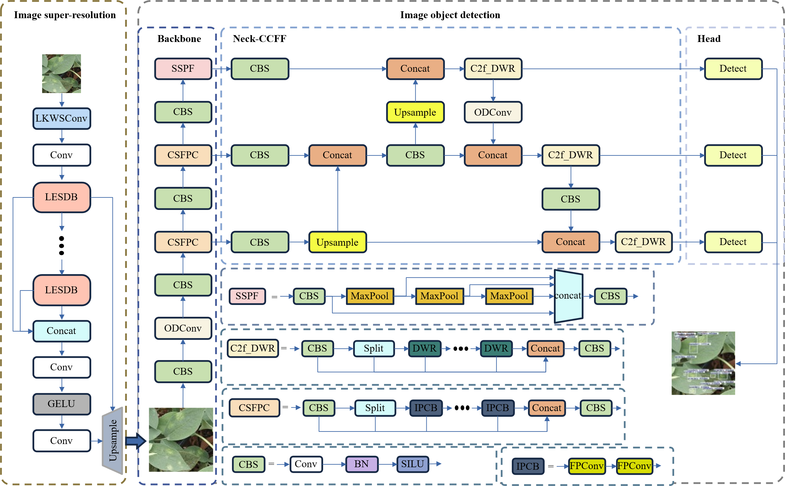

Fig. 3. LBSR-YOLO algorithm structure

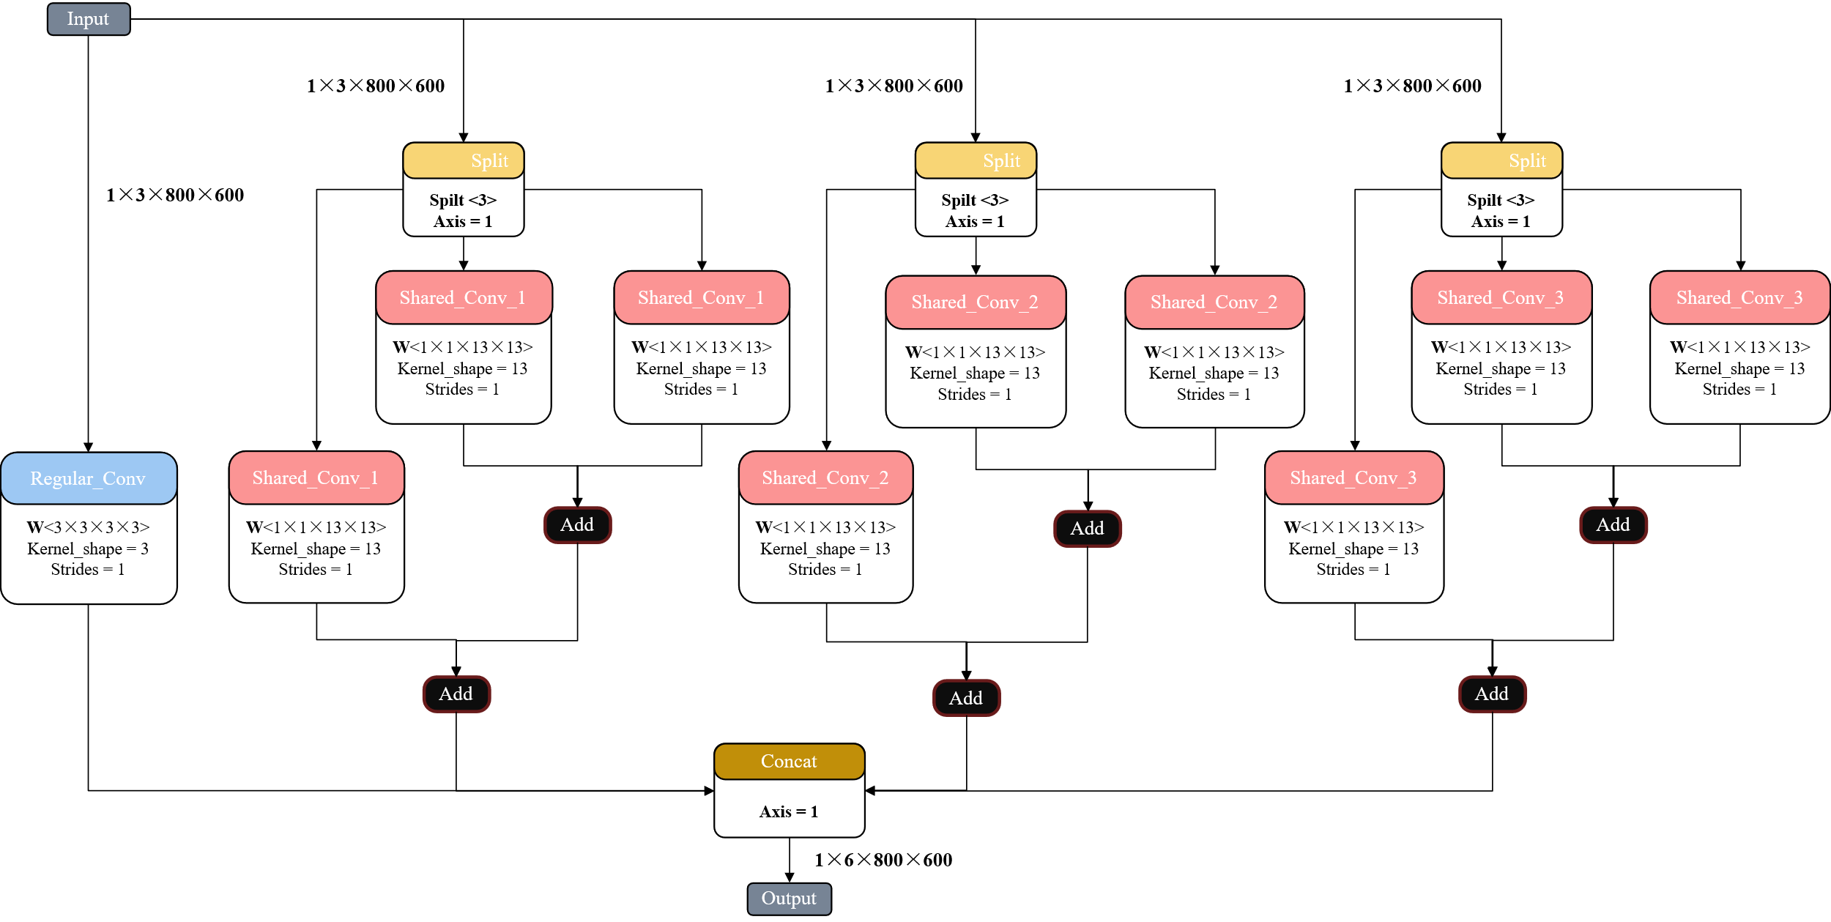

Fig. 4. Large Kernel Weight Sharing Convolution

|  |  |  |  |  |
| --- | --- | --- | --- | --- |
| LR-432×432  Nutrient deficiency |  |  |  |  |
| GT  PSNR/SSIM | Bicubic  24.905/0.957 | FSRCNN  26.036/0.950 | PAN  26.923/0.962 |
|  |  |  |  |
|  | VapSR  27.021/0.965 | RFDN  26.985/0.963 | BSRN  27.036/0.966 | Ours  26.860/0.960 |
| LR-864×864  Powdery mildew |  |  |  |  |
| GT  PSNR/SSIM | Bicubic  28.666/0.945 | FSRCNN  31.022/0.963 | PAN  32.074/0.971 |
|  |  |  |  |
|  | VapSR  32.251/0.973 | RFDN  32.240/0.973 | BSRN  32.525/0.975 | Ours  31.586/0.967 |

Fig. 7. The actual operation comparison of each image super-resolution reconstruction algorithm

See PPT files in the same directory.

Fig. 8. The actual operation comparison of each target detection algorithm

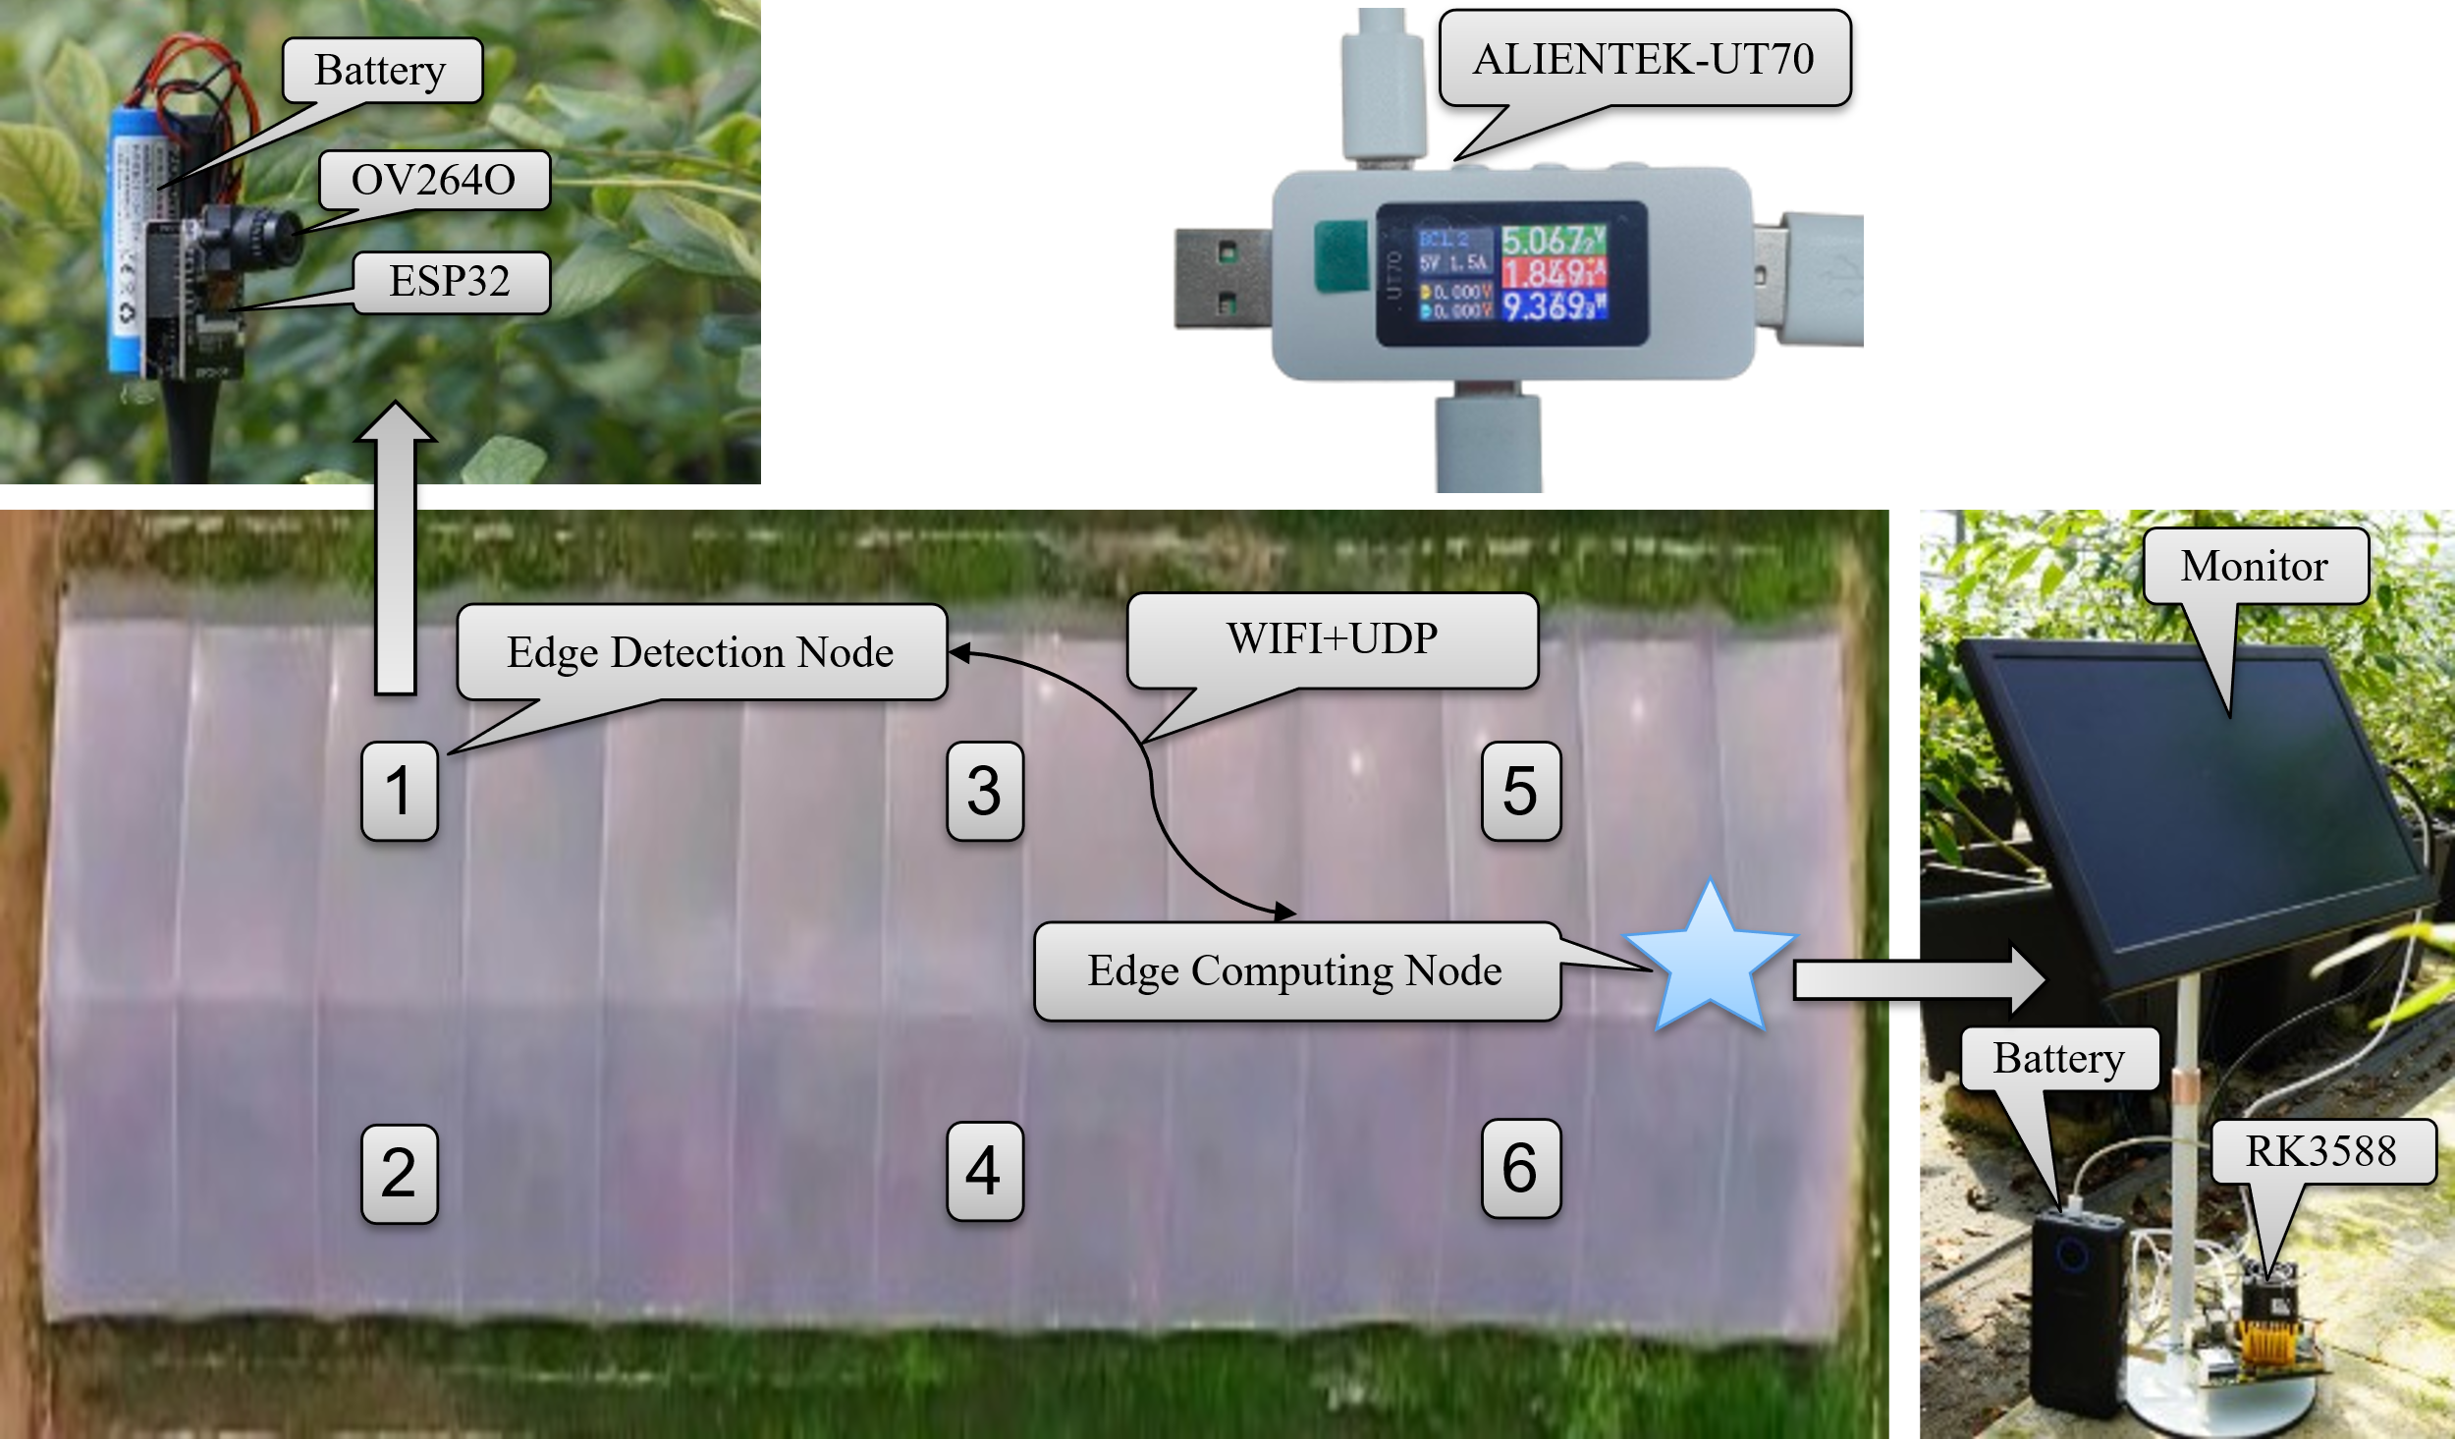

Fig. 9. Deployment of LBSR-YOLO and WSN

|  |  |
| --- | --- |
|  |  |
| (a) | (b) |
| Fig.10 Energy consumption of edge detection node. (a) Energy consumption of single picture acquisition and transmission. (b) The endurance of continuous image acquisition and transmission | |

|  |  |
| --- | --- |
|  |  |
| (a) | (b) |

Fig. 11. Energy consumption of edge computing nodes. (a) Image super-resolution reconstruction algorithm. (b) Image target detection algorithm

|  |  |  |  |
| --- | --- | --- | --- |
| Sensor 1 |  |  |  |
| Sensor 2 |  |  |  |
| Sensor 3 |  |  |  |
|  | Image acquisition | Image super-resolution | Image recognition |

Fig. 12 Field deployment function display